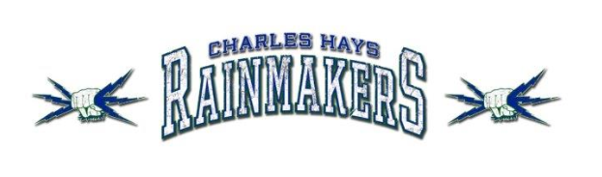

Student Name:

Russell Hood (Crested Full Front)
Colour | Small | Medium | Large | XL | XXL
Charcoal

Russell Lightweight Hood (Crested Full Front)
Colour | Small | Medium | Large | XL | XXL
Oxford/Royal

Soft style T-Shirt (Crested Full Front)
Colour | Small | Medium | Large | XL | XXL
Heather Royal
Dark Heather

Jogger Pant (Embroidered Left Thigh)
Style | X-Small | Small | Medium | Large | XL | XXL
Men’s- Charcoal
Ladies- Charcoal

Pom Pom Toque (Embroidered Front)
Colour | One Size Fits All
Navy

